**Testing on Live application: -**

1. **What is RDBMS?**
   * RDBMS stands for Relational Database Management System. RDBMS is the basis for SQL, and for all modern database systems like MS SQL Server, IBM DB2, Oracle, MySQL, and Microsoft Access.
   * A Relational database management system (RDBMS) is a database management system (DBMS) that is based on the relational model as introduced by E. F. Codd.
   * Most of today's databases are relational:
     1. database contains 1 or more tables
     2. table contains 1 or more records
     3. record contains 1 or more fields
     4. fields contain the data
   * So why is it called "relational"?
   * tables are related (joined) based on common fields
2. **What is SQL?**
   * SQL tutorial gives unique learning on Structured Query Language and it helps to make practice on SQL commands which provides immediate results.
   * SQL is a language of database, it includes database creation, deletion, fetching rows and modifying rows etc.
   * SQL is an ANSI (American National Standards Institute) standard but there are many different versions of the SQL language.
   * SQL is the standard programming language of relational DBs
   * SQL is a standard computer language for accessing and manipulating databases.
   * SQL is a great example of a declarative programming language
     1. Your declare what you want, DB engine figures out how…
   * SQL is Structured Query Language, which is a computer language for storing, manipulating and retrieving data stored in relational database.
   * SQL is the standard language for Relation Database System. All relational database management systems like MySQL, MS Access, Oracle, Sybase, Informix, postures and SQL Server use SQL as standard database language.
   * Also, they are using different dialects, such as:
   * MS SQL Server using T-SQL, ANSI SQL
   * Oracle using PL/SQL,
   * MS Access version of SQL is called JET SQL (native format) etc.
3. **Write SQL commands?**
   * DDL – Data Definition Language
   * DML – Data Manipulation Language
   * DCL – Data Control Language
   * DQL – Data Query Language
4. **What is join?**
   * Join is used to combine and get the data from different table
5. **Write type of joins?**
   * SQL Join type:
     1. INNER JOIN: returns rows when there is a match in both tables.
     2. LEFT JOIN: returns all rows from the left table, even if there are no matches in the right table.
     3. RIGHT JOIN: returns all rows from the right table, even if there are no matches in the left table.
     4. FULL JOIN: returns rows when there is a match in one of the tables.
6. **How many constraint and describe itself?**
   * Mainly these are the type of constraint used in SQL
     1. NOT NULL - Ensures that a column cannot have a NULL value
     2. UNIQUE - Ensures that all values in a column are different
     3. PRIMARY KEY - A combination of a NOT NULL and UNIQUE. Uniquely identifies each row in a table
     4. FOREIGN KEY - Prevents actions that would destroy links between tables
     5. CHECK - Ensures that the values in a column satisfies a specific condition
     6. DEFAULT - Sets a default value for a column if no value is specified
     7. CREATE INDEX - Used to create and retrieve data from the database very quickly
7. **Difference between RDBMS and DBMS?**

|  |  |  |
| --- | --- | --- |
| **Parameter** | **DBMS** | **RDBMS** |
| Storage | [DBMS](https://www.guru99.com/dbms-tutorial.html) stores data as a file. | Data is stored in the form of tables. |
| Database structure | DBMS system, stores data in either a navigational or hierarchical form. | [RDBMS](https://www.guru99.com/difference-dbms-vs-rdbms.html) uses a tabular structure where the headers are the column names, and the rows contain corresponding values |
| Number of Users | DBMS supports single user only. | It supports multiple users. |
| ACID | In a regular database, the data may not be stored following the ACID model. This can develop inconsistencies in the database. | Relational databases are harder to construct, but they are consistent and well structured. They obey [ACID](https://www.guru99.com/dbms-transaction-management.html) (Atomicity, Consistency, Isolation, Durability). |
| Type of program | It is the program for managing the databases on the computer networks and the system hard disks. | It is the database systems which are used for maintaining the relationships among the tables. |
| Hardware and software needs. | Low software and hardware needs. | Higher hardware and software need. |
| Integrity constraints | DBMS does not support the integrity constants. The integrity constants are not imposed at the file level. | RDBMS supports the integrity constraints at the schema level. Values beyond a defined range cannot be stored into the particular RDMS column. |
| Normalization | DBMS does not support Normalization | RDBMS can be Normalized. |
| Distributed Databases | DBMS does not support distributed database. | RBMS offers support for distributed databases. |
| Ideally suited for | DBMS system mainly deals with small quantity of data. | RDMS is designed to handle a large amount of data. |
| Dr. E.F. Codd Rules | Dbms satisfy less than seven of Dr. E.F. Codd Rules | Dbms satisfy 8 to 10 Dr. E.F. Codd Rules |
| Client Server | DBMS does not support client-server architecture | RDBMS supports client-server architecture. |
| Data Fetching | Data fetching is slower for the complex and large amount of data. | Data fetching is rapid because of its relational approach. |
| Data Redundancy | Data redundancy is common in this model. | Keys and indexes do not allow Data redundancy. |
| Data Relationship | No relationship between data | Data is stored in the form of tables which are related to each other with the help of foreign keys. |
| Security | There is no security. | Multiple levels of security. Log files are created at OS, Command, and object level. |
| Data Access | Data elements need to access individually. | Data can be easily accessed using SQL query. Multiple data elements can be accessed at the same time. |
| Examples | Examples of DBMS are a file system, XML, Windows Registry, etc. | Example of RDBMS is MySQL, Oracle, SQL Server, etc. |

1. **What is API testing?**
   * Application Programming Interface (API) is a software interface that allows two applications to interact with each other without any user intervention
   * Another definition, API (Application Programming Interface) is a computing interface which enables communication and data exchange between two separate software systems.
   * The purpose of API Testing is to check the functionality, reliability, performance, and security of the programming interfaces.
   * In API Testing, instead of using standard user inputs (keyboard) and outputs, you use software to send calls to the API, get output, and note down the system’s response.
   * API tests are very different from GUI Tests and won’t concentrate on the look and feel of an application.
2. **Types of API testing?**
   * There are mainly three type of API testing performed
     1. **Open APIs**: These types of APIs are publicly available to use like OAuth APIs from Google. It has also not given any restriction to use them. So, they are also known as Public APIs.
     2. **Partner APIs**: Specific rights or licenses to access this type of API because they are not available to the public.
     3. **Internal APIs**: Internal or private. These APIs are developed by companies to use in their internal systems. It helps you to enhance the productivity of your teams.
3. **What is responsive testing?**
   * A responsive web design involves creating a flexible web page that is accessible from any device, starting from a mobile phone to a tablet.
   * Furthermore, a responsive web design improves users’ browsing experience.
   * Considering this from a quality assurance perspective, a responsive web design requires thorough evaluation using a variety of devices before it is ready to go live.
   * Software testers may find it challenging to perform responsive design testing as a variety of factors are to be looked into during the testing phase.
   * Some points to be understand for Responsive Testing.
     1. The challenges involved in testing a responsive website
     2. How website testing differs from a mobile device to a computer
     3. Rules and guidelines to be followed during responsive design testing and
     4. Lastly, various tools available to perform responsive testing
4. **Which type of tools are available to execute responsive testing?**
   * Responsive testing tools are:
     1. LT Browser
     2. Lembda Testing
     3. Google Resizer
     4. I am responsive
     5. Pixel tuner
5. **What is the full form of .IPA, .APK?**
   * **.IPA :** IOS App Store Package
   * **.APK :** Android Application Package
6. **How to create step for open developer option mode on?**

* Go to "Settings"



* Tap "About device" or "About phone"

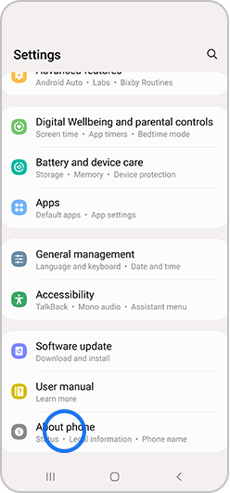

* Tap “Software information”

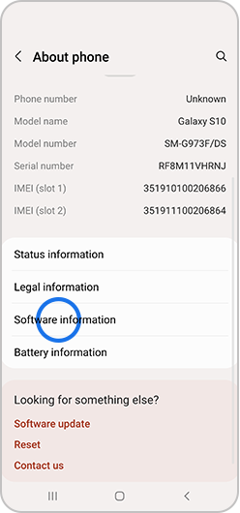

* Tap “Build number” seven times

Depending on your device and operating system, you may not need to follow step number 3.

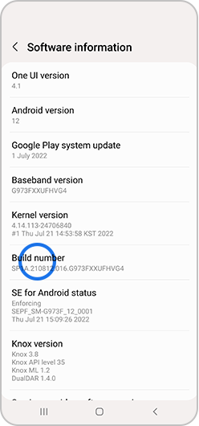

* Enter your pattern, PIN or password to enable the Developer options menu
* The "Developer options" menu will now appear in your Settings menu

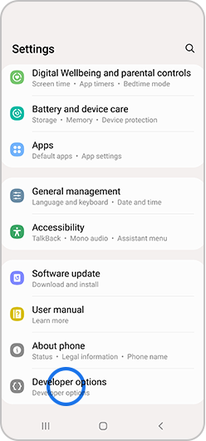

Depending on your device, it may appear under Settings > General > Developer options.

* To disable the Developer options menu, tap the switch

